**BF[1] – Multiple Comparisons Cortland Watson**

**Type in your score here 🡪 __22__ out of 25 points possible**

1. (5 points) Ponder/Reflect Exercise – Reflect on what you have learned from this portion of the class. Examples of what you can do are: a brief outline of material covered, insights you gained from class or personal study, or items you feel that you need to follow up or work on. (3-5 sentences)
   1. I am grateful for this week, and sad that I missed this assignment on time. I am glad that we have the opportunity to learn about multiple comparisons and how expanding our scope increases the potential that we have in grasping knowledge. Multiple comparisons help us to broaden our view and see how different factors can effect a single response in different ways.
2. In this problem, you will use SAS or R to do a complete analysis of variance on the head injury severity scores associated with 7 types of cars. The data are found in the file headinjury.csv (note that it is comma-delimited) or SAS filename *headinjury*.
   1. (3 points) Give the name of the appropriate design for these data and write down the statistical model, carefully defining on the parameters in the model.
      1. Basic Factorial Design
   2. (3 points) Our primary interest is to see if the car types have different mean head-injury severity scores. Write down the appropriate null and alternative hypotheses, carefully defining all symbols.
      1. Our null hypothesis is that the all means are equal to zero or that the car type has no effect on head injury.
      2. Our alternative hypothesis is that at least one of the means is not 0 and that the car type has an effect on the injuries.
   3. (3 points) Give the ANOVA table and interpret the proper F-test for the hypotheses of interest.
      1. Df Sum Sq Mean Sq F value Pr(>F)
      2. -------- ---- --------- --------- --------- ----------
      3. Type 6 2708060 451343 3.41 0.005612
      4. Res 63 8338789 132362
   4. (3 points) Do a pairwise comparison test using the following four methods: :
      1. Tukey's HSD
         1. 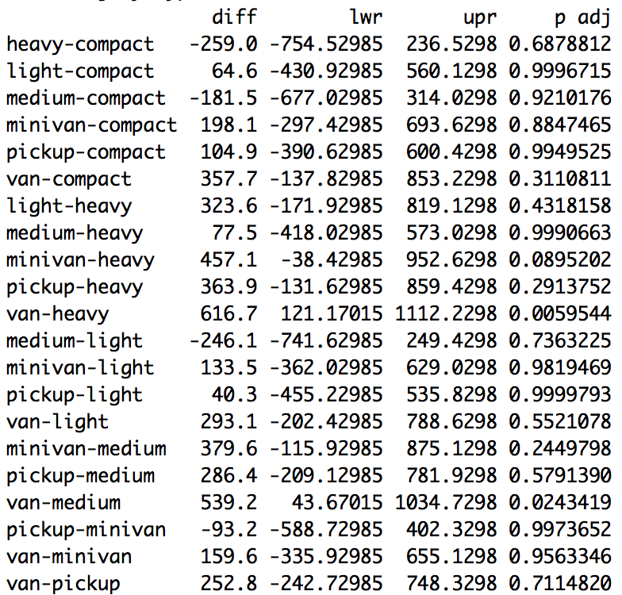
      2. Scheffe'
         1. 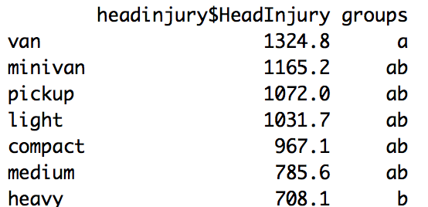
      3. Bonferroni
         1. 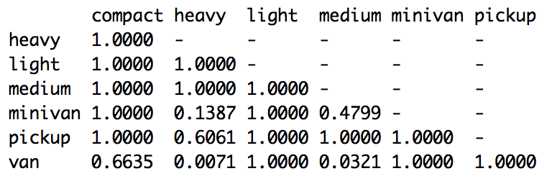
      4. Fisher’s LSD
         1. 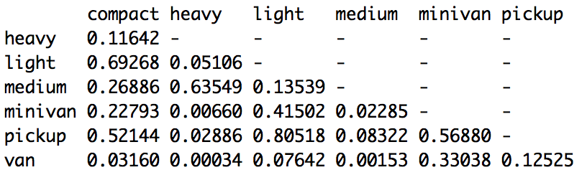
3. Out of the four methods: (i) Tukey's HSD, (ii) Scheffe', (iii) Bonferroni, and (iv) Fisher’s LSD, choose the best method given the following scenarios:
   1. (2 points) You would like to do an exploratory analysis to see which means or contrasts are different.
      1. Scheffe
   2. (2 points) Based on the structure of the data, you know which contrasts or comparisons you know the 3 comparisons or contrasts that you want to make.
      1. Bonferroni
   3. (2 points) You are interested in all pairwise comparisons, but you want to keep your family-wise Type I error rate at 0.05.
      1. Tukey
   4. (2 points) You are interested in all pairwise comparisons, but you want the capacity to detect any real differences.
      1. Fisher